**HOW TO COPY MULTIPLE TABLES FROM DATABASE IN A SINGLE PIPELINE ACTIVITY.**[**https://www.youtube.com/watch?v=KsO2FHQdILs**](https://www.youtube.com/watch?v=KsO2FHQdILs) **GET LIST OF TABLES  
SQL QUERY  
  
Select databasename.information schema.Tables  
  
Create Look Up Table Data Base where list of tables are available for look up**Create table [dbo].[Look Up Table](

Schema_Name varchar(30) null,

Table_Name varchar(30) null

);

Insert into [dbo].[Look Up Table]([Schema_Name],[Table_Name])

values('dbo','Client'),

('dbo','AccountData'),

('dbo','Transactions'),

('dbo','LoanData');

Select * from dbo.[Look Up Table]  
Bring Look up table in warehouse workspace  
  
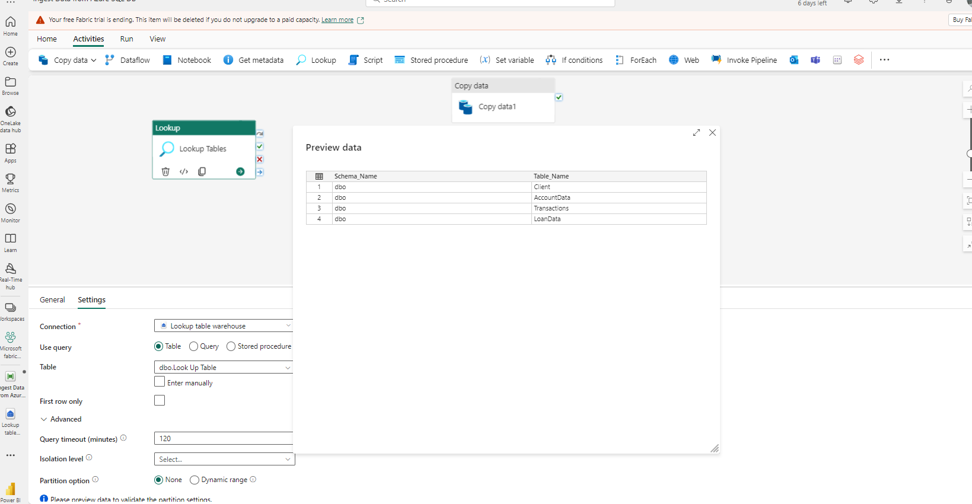  
  
Create two(02) variables

First Variable Set up  
  
2nd Variable Setup

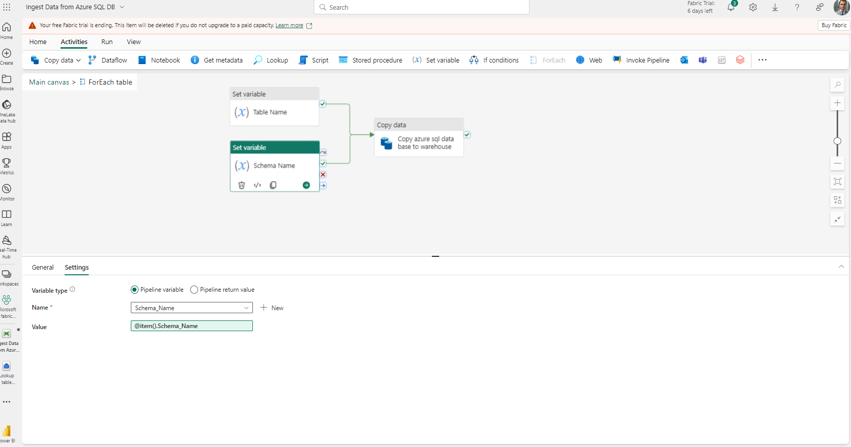

@concat('select * from ',variables('Schema_Name'), '.’ ,variables('Table_Name'))   
  
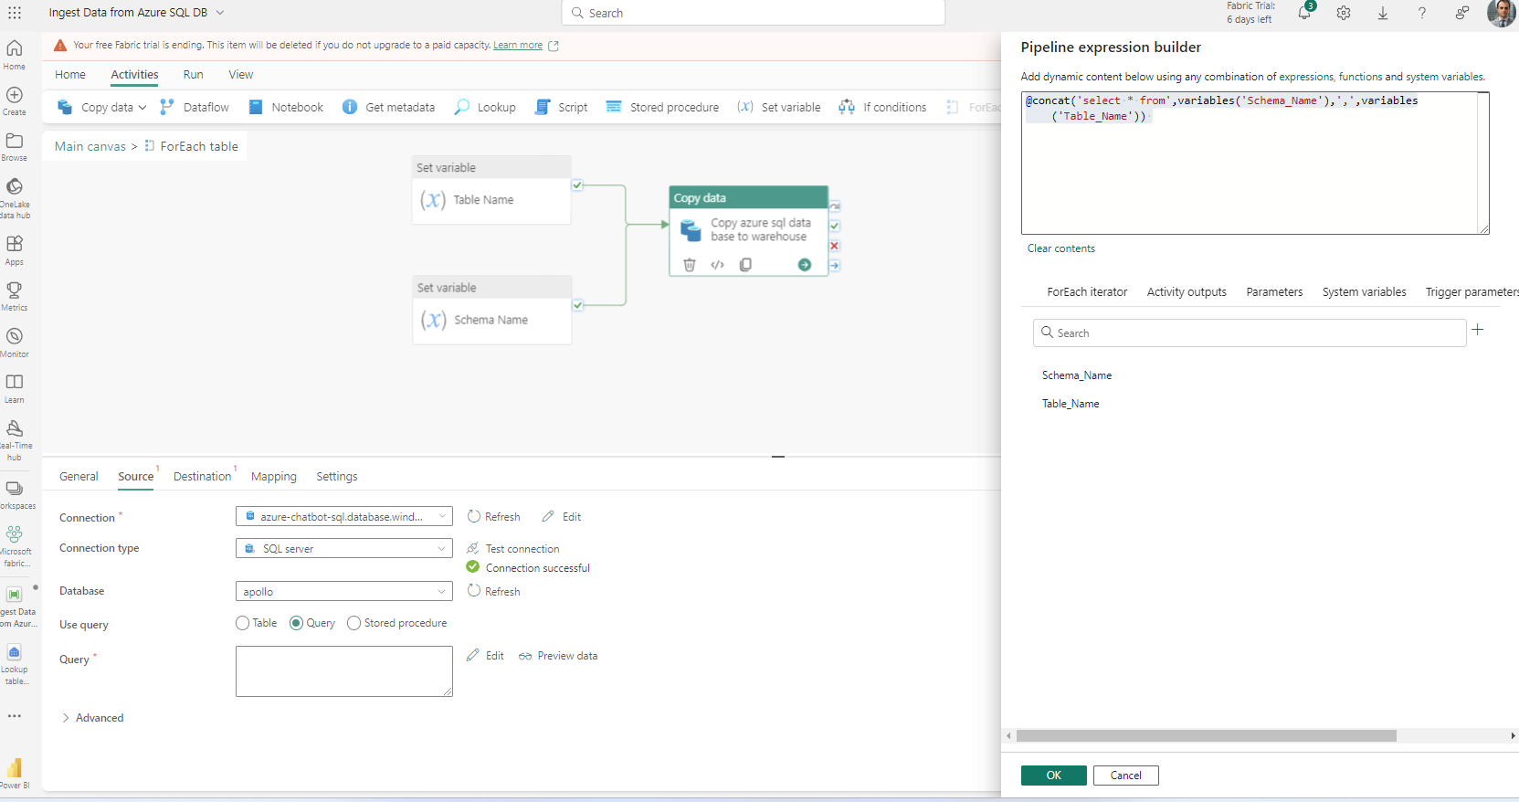

Set Up Destinations in Azure Data Factory.

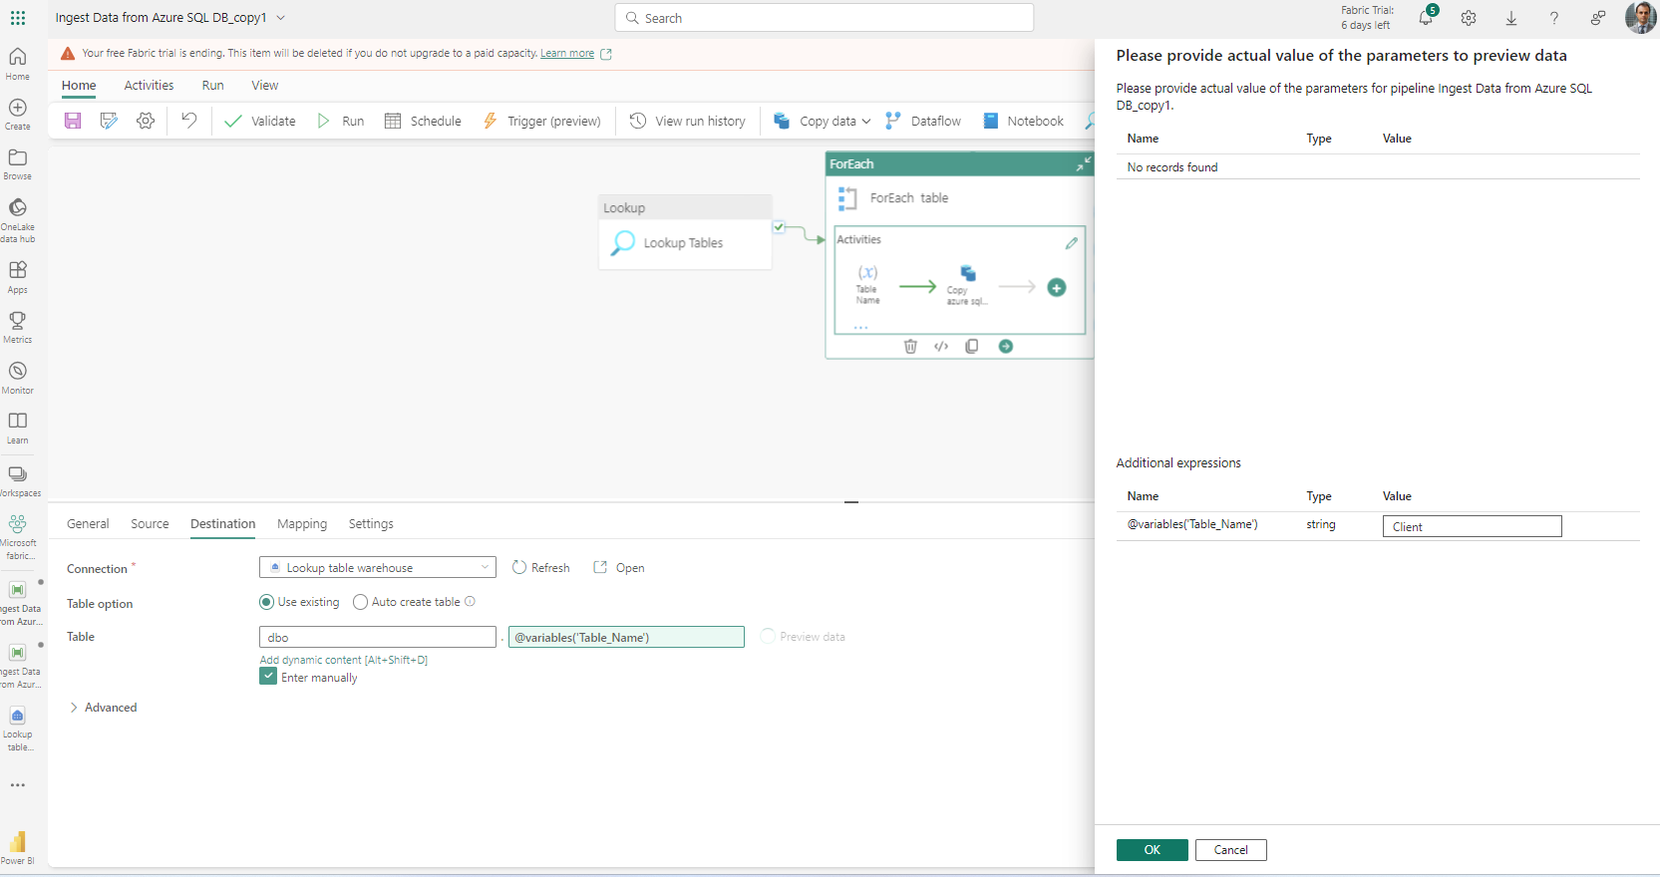

Destinations Step  
You need to create a tables in Datawarehouse  
  
  
create table dbo.AccountData (

AccountNo  int not null,

ClientID  int  not null,

AccountBalance decimal(18,6) not null,

Date date not null)

create table dbo.Transactions (

TransactionsID  int not null,

AccountID  int  not null,

TransactionDate date null,

Amount decimal(18,2)  null,

TransactionType varchar(20) null

)

create table dbo.LoanData (

LoanNumber  int null,

ClientID  VARCHAR(30) null,

LoanType varchar(50) null,

Loan_status varchar(50)  null,

LoanDueDate  date null,

Original_Loan_Paid_Amount(VARCHAR(50), null,

Loan_Outstanding_Balance(Varchar(50), null,

LoanPaidDate date,null,

Sector varchar(50) null,

Client varchar(50) null

)  
  
When copying Multiple Tables The Source Schema and the destination must be the same.  
